Galileo and the motion of Projectiles ____________________
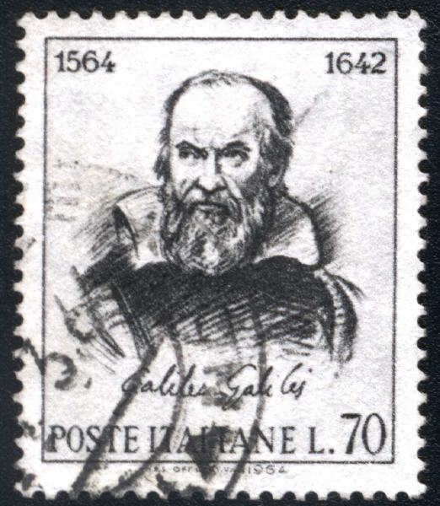
Galileo Galilei (1564 – 1642) was an Italian scientist who formulated the basic law of falling bodies, which he verified by careful measurements. He constructed a telescope with which he studied lunar craters, and discovered four moons revolving around Jupiter and espoused the Copernican cause.
http://www-history.mcs.st-andrews.ac.uk

Although Galileo spent much of his time studying and writing about astronomy, he also made some important discoveries about the motion of projectiles under the force of gravity. Here are two important discoveries in this area:

A. The height (vertical position) of a projectile under the influence of gravity is a quadratic function of time. ,
where “a” is exactly one half of the force of _________________,
“b” is the initial ______________________ of the projectile, and
“c” is the initial ______________________ of the projectile.

So, for the equation ,
-the force of gravity is _____________ meters per second, per second (directed downward),
-the initial speed of the projectile was _______ (directed upward),
-the projectile was released from an initial height of ______________ meters above the ground.

B. The horizontal motion of a projectile is independent of the vertical motion (neglecting air resistance).
Galileo’s thought experiment: a ball is dropped from the top of the mast of a motionless sailboat. Suppose it takes 1.3 seconds to hit the deck of the boat. Now consider the same ball dropped from the same point, but now the sailboat is moving horizontally through the water. How long does it take the ball to hit the deck? (read more at www.pbs.org/wgbh/nova/galileo/expe_proj_1.html)

For some additional fun in the area of projectile motion, go to http://jersey.uoregon.edu/vlab/Cannon/ and fire some cannons!

1. Robin Hood is hiding out in his tree house 20 meters above the ground, and he sees the Sherriff of Nottingham in the distance on horseback. Robin Hood’s arrow “zings” into the air at a 40° angle (above the horizontal) and a velocity of 30 meters per second. Assume that Robin releases the arrow (from a kneeling position) exactly 1 meter off the tree house floor.
- Sketch the velocity triangle for RH’s arrow, and use trigonometry to find the horizontal and vertical components of that velocity.
- Write parametric equations for the location of the arrow at any time, t. (remember: we’re using meters now)
- Complete the chart below and plot the path of the arrow at 1-second intervals.
- Find the time (and location) at which the arrow reaches its peak height. Plot this point with a diamond.
- Find the time (and location) at which the arrow reaches it’s original height above the ground. Plot this point with a square.
Comment on this time as it relates to the time the arrow reached its peak height.
- Find the time (and location) at which the arrow hits the ground (assuming RH isn’t a good aim). Plot this point with a star.
- If the Sherriff of Nottingham is 1.9 meters tall (with his fancy boots on), in what x-interval is he in danger of getting hit with the arrow?

t (seconds) | 0 | 1 . | 2 . | . | . | . | .
x (horiz.) | 0
y (vertical) | 21

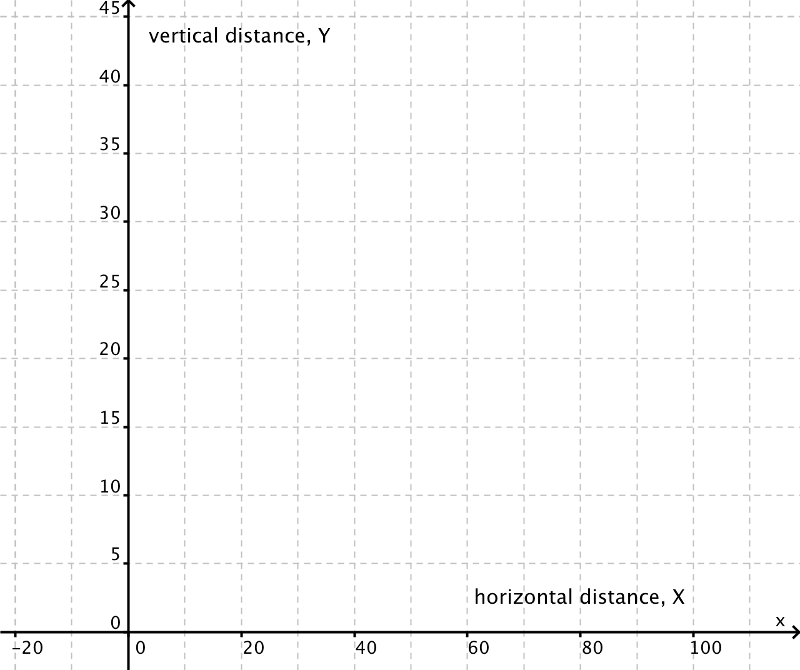

2. An airplane is flying due east with a speed of 90 feet per second, at an elevation of 1000 feet. At just the right moment (we’ll call it t = 0 seconds), one of the crew members shoves a package (containing food and medical equipment) out of the airplane. Your job is to track the location of the package as it falls to earth.
Concepts from physics:
-the horizontal motion can be analyzed independently from the vertical motion
-since there is no acceleration (gaining/losing speed) in the horizontal direction, the distance equation for the horizontal motion is simply
-we are neglecting air resistance, so we only consider gravity as a force of acceleration in the vertical direction.
- Therefore, the distance equation for the vertical motion is 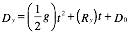 Note: gravity, g = -32 fps/s, or -9.8 mps/s
- Find the equations for the two components of motion.
- Complete the chart below, plotting an (x,y) coordinate for every second that the package is in the air (label each point with the time).
- At what time (and location) has the package fallen halfway to the earth? Plot this point with a square.
- At what time (and location) does the package hit the earth? Plot this point with a star.
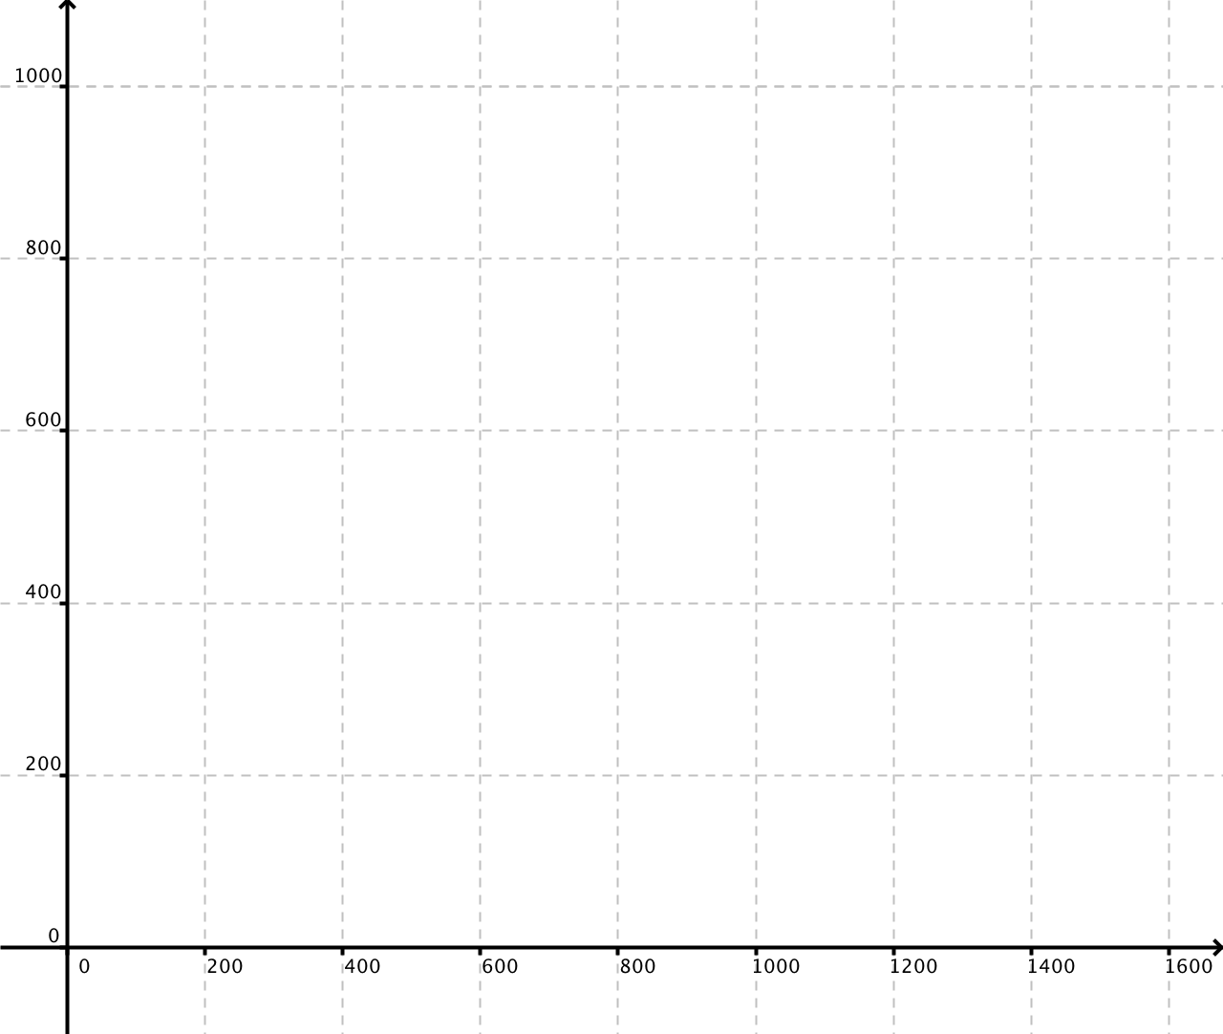

t (seconds) | 0 | 1 . | 2 . | . | . | . | . | . | . | .
x (horiz.) | 0
y (vertical) | 1000

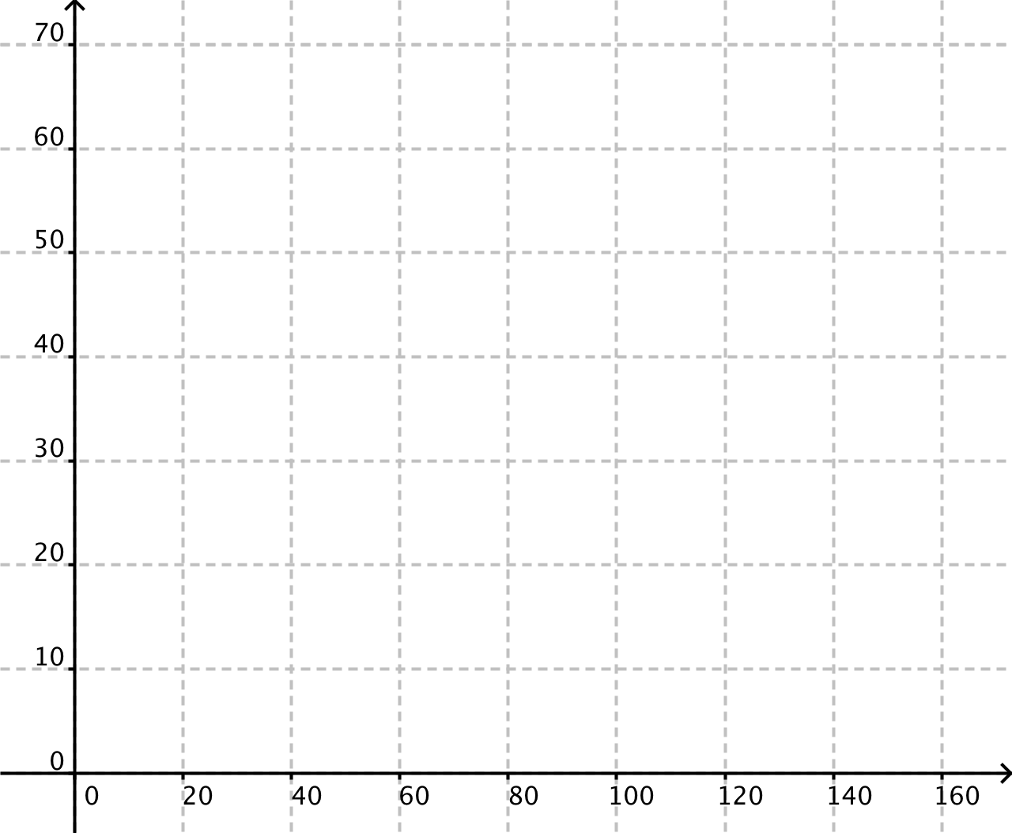
3. Now suppose Robin Hood is standing on the ground so that his arrow leaves the bow at exactly 1.5 meters above the ground. This time, Robin shoots his arrow into the air at a 30° angle (above the horizontal) with a velocity of 40 meters per second.

On a separate sheet of paper, develop equations for the vertical and horizontal position of the arrow.
Complete a Table of (T, x, y) values similar to the ones above, and plot the graph of the projectile on the axes at right.
Be sure to include (in your table AND your plot) the Apex point (highest point) and the Impact point (where the arrow hits the ground).

4. Since Robin Hood remembers high school with nostalgia, he strings his next arrow and sends it off at the complement of 30°, keeping everything else the same as before. Repeat question three for this arrow’s flight.

5. For reflection: Consider the following quotes from Galileo.

“I do not feel obliged to believe that the same God who endowed us with sense, reason, and intellect intended us to forgo their use.”
Quoted in Des MacHale, Wisdom (London, 2002).

- Re-write this quote in your own words.

b. What does this quote reveal about Galileo’s beliefs?

“ [The universe] cannot be read until we have learnt the language and become familiar with the characters in which it is written. It is written in mathematical language, and the letters are triangles, circles and other geometrical figures, without which means it is humanly impossible to comprehend a single word.” Opere Il Saggiatore p. 171.

c. How does this quote connect to your own study of mathematics?

